Wendy Houstoun

Watch it!

Technical
Specifications

CREATIVE TEAM
Concept, Direction, Performer: Wendy Houstoun
Hannes Langolf
Kate Champion
Lighting Design: Marty Langthorne

TRAVELLING COMPANY

Touring company: 2 people (Wendy & Marty)

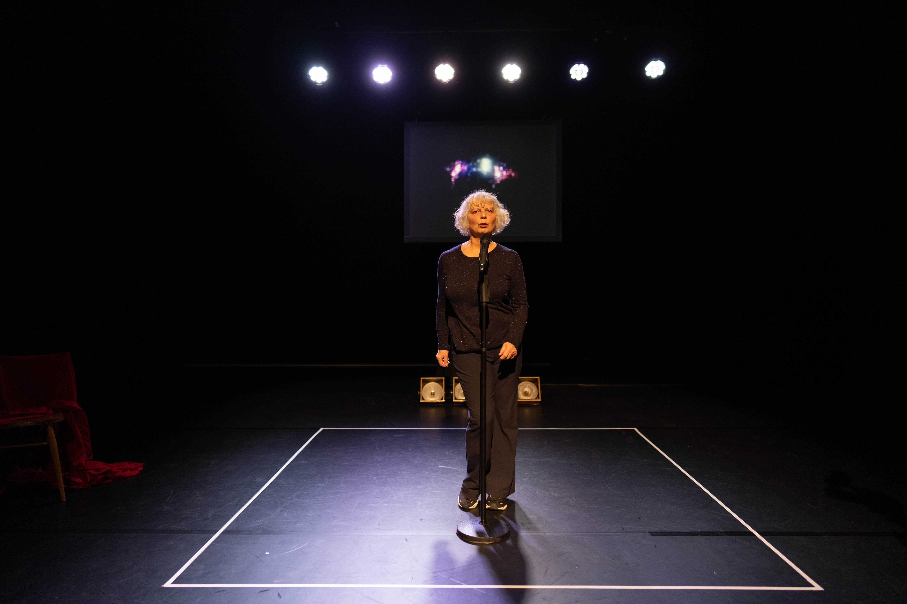

Staging

Minimum Playing area
- 5m deep x 8m wide

COMPANY PROVIDEs
- Small suspended projection screen 1370mm x 1030mm.
- Taped square on dance floor using 25mm grey PVC tape, square measuring 2.5m x 2.5m

Masking
PROVIDED BY VENUE
- We required 2 sets of legs, 1 downstage and 1 upstage
- We require a set of black tabs at the back of the performance space

Dance Floor
PROVIDED BY VENUE
- We require a black dance floor that is clean and taped with black dance floor tape. It will require cleaning each day.

Props
PROVIDED BY VENUE
- Black wooden chair

Lighting

PROVIDED BY VENUE
- We require an ETC EOS lighting console
- 2 booms per side
- 6 x LED pars either D60 Lustr, D40 Lustr or coloursource pars
- These should be rigged on a low bar 3m long at the rear of the performance area at +4000mm high
- Venue specific lighting plan to be provided, please see generic plan below to give you an idea.
- Operating position with a clear uninterrupted view of the stage
- Lighting operated by company lighting designer

COMPANY PROVIDES
- 4 x PAT 60 gold square lights placed on the dance floor at the rear of the square, these are pat tested, we require a small black board for these to sit on so that we don’t harm your dance floor
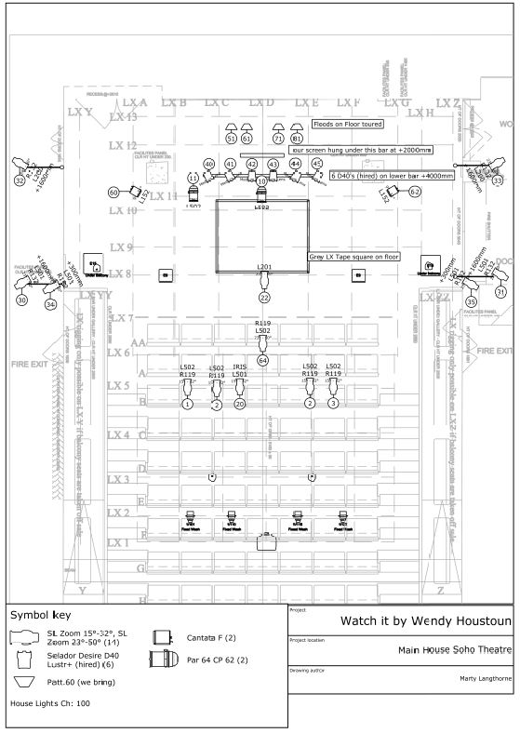

Sound

The sound for the piece is spoken word using a handheld radio microphone and playback music via Qlab.

Operation position
- At the back of the seats, not in a rear booth so that it is possible to hear the sound clearly & next to lights

Control
COMPANY PROVIDES
- Mac mini to run sound and video

Speakers
PROVIDED BY VENUE
- Stereo PA with subs appropriate to venue, coverage to every seat.

Microphones
PROVIDED BY VENUE
- 1 handheld radio mics (Shure beta 58 or similar)
- 1 straight roundbase mic stand with push clip to extend height, this should be lightweight and easy for the performer to move around.
- The microphone will need to have coverage from the dressing room as the performer will use this in the dressing room towards the end of the show

Video
VENUE TO PROVIDE
- High quality projector to front project onto our screen 1370mm x 1030mm, hanging 2m high.
- We will scale the image in Qlab to fit our screen
- Once the image is scaled in Qlab we may need to turn the brightness down and contrast up on the projector so that we don’t have a square of light around the screen.
- We require an HDMI connection into our mac mini from your projector

Dressing Rooms
PROVIDED BY PRESENTER
- 1 dressing room side stage for the performer

Water
PROVIDED BY PRESENTER
- Please provide a water cooler for the performer backstage

FOH
Warnings
- Haze
- Slow flashing lights

Latecomers
- No latecomers but we’re happy to start the show a little later.
- Running time 60mins no interval

Schedule and get-in Crew

GENERIC PRODUCTION SCHEDULE

Assuming a pre-rig is possible

1st Day
10:00am – 1:00pm rig screen
Focus projector
Rig low lighting bar 2 crew
Rig Booms

Sound install

1:00pm – 2:00pm lunch

2:00pm – 5:00pm focus lights
Cue to cue with performer 2 crew

5:00pm – 8:00pm rehearsal time 1 crew

2nd Day
10:00am – 1:00pm tech fix ups time 1 crew

2:00pm – 6:00pm warm up
Dress Rehearsal 1 crew
Notes

8:00pm Opening Performance 1 crew

Show Crew
PROVIDED BY PRESENTER
- 2 x venue tech

